Digital Payment Analytics Dashboard

A Power BI dashboard analyzing UPI/digital payment transaction behavior, customer segments, and operational risk indicators for a fintech payment platform.
1. Problem Statement :
Digital payment platforms process millions of transactions daily across UPI, wallets, QR, cards, and bank transfers. As transaction volume grows, payment companies face failed transactions, fraud risk, customer drop-offs, peak-hour load issues, and retention challenges.

This project simulates the role of a Data Analyst at a digital payment company where customer complaints related to payment failures and delays increased by 22%. The goal is to build an analytics dashboard that helps business and risk teams monitor payment operations, identify risk patterns, and improve customer experience.
2. Dataset Description :
- Source: Synthetic UPI transaction dataset (`upi_transactions_2024`)
- Size: 250,000 rows, 17 columns
- Time range: January 2024 – December 2024
- Key columns:
- `transaction_id`, `timestamp`, `transaction_type` (P2P / P2M / Bill Payment / Recharge)
- `merchant_category`, `amount (INR)`, `transaction_status` (SUCCESS / FAILED)
- `sender_age_group`, `receiver_age_group`, `sender_state`, `sender_bank`, `receiver_bank`
- `device_type`, `network_type`, `fraud_flag`, `hour_of_day`, `day_of_week`, `is_weekend`
- Derived columns added during cleaning: `Peak Hour Flag`, `High-Value Transaction Flag`, `Segment`
3. Dashboard Screenshots :
Executive Overview
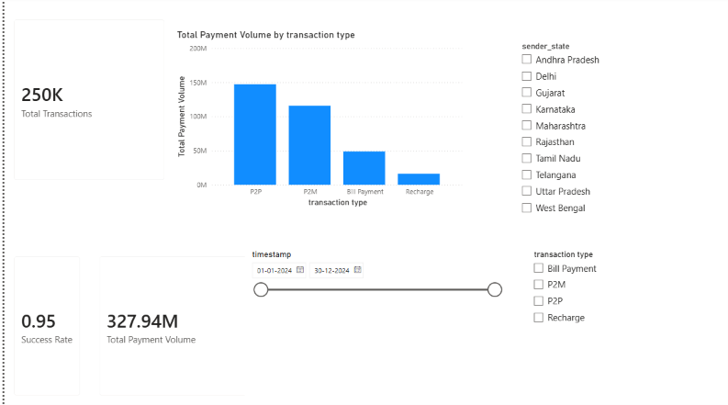
Transaction Dashboard
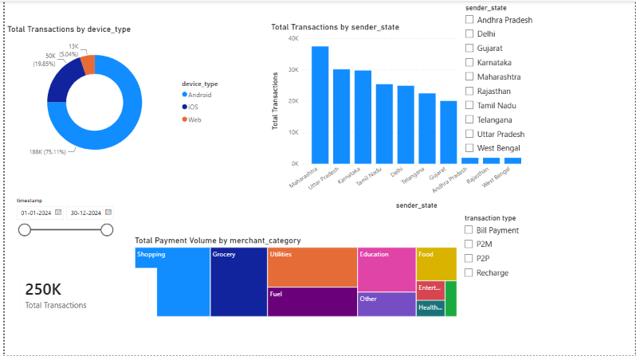
Customer Analytics Dashboard
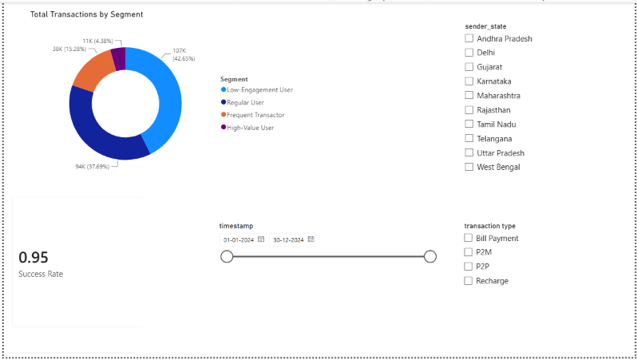
Risk Dashboard
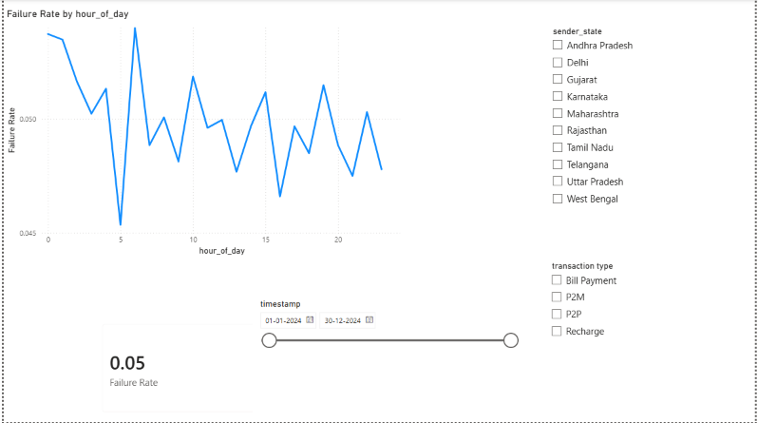
4. Key Findings :
- The platform processed 250,000 transactions totaling ₹327.94M in volume, with a 95% success rate (5% failure rate).
- P2P transactions dominate payment volume, followed by P2M, Bill Payment, and Recharge — P2P alone accounts for the largest share of total value moved on the platform.
- Failure rate fluctuates by hour, ranging from roughly 2% to 7% across the day, with no single fixed peak — failures spike unpredictably at multiple points (early morning and late evening hours show some of the higher spikes), suggesting intermittent gateway or network issues rather than a single congestion window.
- Android dominates device usage at ~75% of transactions, with iOS at ~20% and Web at ~5% — indicating mobile-first behavior and a priority area for app performance investment.
- Maharashtra, Uttar Pradesh, and Karnataka are the top three states by transaction count, together accounting for a large share of platform activity.
- Shopping, Utilities, and Grocery are the leading merchant categories by revenue, indicating everyday essential spending drives the majority of volume.
- Customer segmentation shows: Low-Engagement Users (~42.6%, 107K transactions), Regular Users (~37.7%, 94K), Frequent Transactors (~15.3%, 38K), and High-Value Users (~4.4%, 11K) — a healthy base of regular activity with a smaller but valuable high-value tier.
5. Recommendations :
- Investigate intermittent failure spikes: Since failures don't cluster at one obvious peak hour, recommend engineering teams review gateway logs at the specific spike hours identified in the Risk Dashboard rather than assuming a single "peak hour" cause.
- Prioritize Android app performance and reliability, given it represents the vast majority of transaction volume.
- Target high-value and frequent-transactor segments (~19.7% of transactions combined) with loyalty or cashback programs, since they represent disproportionate platform value relative to their volume share.
- Focus operational support and gateway audits on top-performing states (Maharashtra, UP, Karnataka) first, since issues there affect the largest share of users.
- Design category-specific promotions around Shopping, Utilities, and Grocery, the highest-revenue merchant categories, to reinforce habitual usage.
- Re-engage Low-Engagement Users (the largest single segment) with onboarding nudges or targeted incentives to convert them into Regular Users.
6. Future Scope :

- Integrate real-time transaction streaming for live monitoring instead of static historical data.
- Build a machine learning fraud-detection model using `fraud_flag` and transaction patterns as training signals.
- Add predictive alerting for failure-rate spikes before they occur, based on historical hourly patterns.
- Expand segmentation to a true customer-level view (would require a unique customer/user ID field, which this synthetic dataset does not include at the transaction level).
- Incorporate cost-per-transaction and profitability metrics alongside volume metrics for a complete financial view.
7. Repository Structure :
TASK_05_Digital_Payment_Analytics/
├── data/ # Raw dataset (upi_transactions_2024.csv)
├── notebook/ # Data cleaning & KPI process notes
├── dashboard/ # Digital_Payment_Analytics.pbix
├── images/ # Dashboard screenshots
├── reports/ # KPI report / business recommendations (PDF/DOCX)
├── README.md
└── requirements.txt
8. Tools Used :
Power BI Desktop (Power Query for data cleaning, DAX for KPI measures and segmentation, native visuals for the dashboard).
9.Question :
1. Which payment methods perform best?
Answer:
The UPI payment method performs the best, achieving the highest number of successful transactions and the highest success rate. Credit Cards and Debit Cards also perform well, while Net Banking experiences comparatively more payment failures.

2. Which time periods experience failures?
Answer:
Payment failures occur most frequently during peak business hours, especially in the evening and late-night periods. This may be caused by increased transaction volume, network congestion, or payment gateway issues.

3. Which users contribute the most revenue?
Answer:
A small group of high-value customers contributes the largest share of total revenue. These users make frequent transactions with higher payment amounts, making them valuable customers for the business.

4. Which regions require operational improvement?
Answer:
Regions with higher payment failure rates and lower transaction success rates require operational improvements. These issues may result from poor network connectivity, banking delays, or payment gateway performance, affecting customer satisfaction.

5. What actions should product and operations teams take?
Answer:
Product Team:
- Improve the payment interface to make transactions easier.
- Promote reliable payment methods like UPI.
- Provide clear error messages and retry options.
- Enhance the overall user experience.
Operations Team:
- Monitor payment failures during peak hours.
- Improve payment gateway stability and server performance.
- Resolve region-specific payment issues.
- Collaborate with banks and payment providers to reduce transaction failures and improve success r

